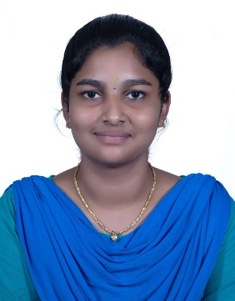**SHALINI P**

**CONTACT DETAILS**

* +91 7904563167
* [shalinicsbs@gmail.com](mailto:shalinicsbs@gmail.com)
* G-18, Aruppukottai,Virudhunagar.
* <http://www.linkedin.com/in/shalini-p-001321290>
* <https://github.com/shalini476>

**PROFESSIONAL SUMMARY**

Results-driven and detail-oriented Software Developer with a strong foundation in programming, problem-solving, and full-stack development. Proficient in designing, developing, and testing scalable applications with a focus on clean code and performance optimization. Eager to contribute to innovative projects in a collaborative team environment**.**

**PROJECT SUMMARY**

**Project Title:** Online Bookstore Management System  
**Duration:** 25 Aug 2023 to 4 July 2025  
**Team Size:** 4  
**Role:** Backend Developer  
**Software/Tools Used:** Java, MySQL, Eclipse IDE  
**Description:** Developed and managed backend logic for a web-based bookstore, including user authentication, inventory handling, and order management.

**INTERNSHIPS**

* **Company Name:** Elysiyum pro technologies

**Duration:** 15 Days

**Role:** Full stack Developer (Java)

**Software/Tools used:** Apache Netbeans, Xampp

* **Company Name:** CodeAlpha

**Duration:** 1 Month

**Role:** Frontend Developer

**Software/Tools used:** VScode

**EDUCATIONAL SUMMARY**

B.Tech., Computer Science and Business Systems

M.Kumarasamy college of engineering

2023-2027

8.059 (upto 3rd semester)

**SKILLS SET**

**TECHNICAL SKILLS**

* Java (Intermediate)
* C, C++ (Intermediate)
* HTML (Basic)

**SOFT SKILLS**

* Problem solving
* Communication
* Leadership

**AREA OF INTEREST**

* Software Design
* Data structure
* Computational Statistics

**CERTIFICATIONS**

* Diploma certification in Python and Certification for C++ from CSC
* Joy of computing using python and Introduction to Iot from NPTEL
* Introduction to Data science from Infosys SpringBoard
* Communication skills from TCS ion
* Fundamentals of Digital Marketing from Google digital garage
* Introduction to data engineering and bigdata from GUVI

**CO-CURRICULAR ACTIVITIES**

* Attended Workshop at Karpagam Engineering college(Antenna design)
* Paper Presentation at KPR institute of Technology (Bigdata analytics)
* Paper Presentation at Paavai engineering college(AI in Education)
* TechQuiz at KGISL institute of technology
* Codathon at KPR institute of Technology

**PERSONAL INFORMATION**

**Father’s name:** R.Parthiban

**Mother’s name:** A.Vidya

**Date of birth:** 04.07.2006

**Languages Known:** English,Tamil

**Date:** 01.08.2025

**Place:** Karur SIGNATURE